Homebrew Buddistick 2010 Plans

Back in 2000, I designed a portable dipole antenna called the “Buddipole”. It incorporated CPVC, a lightweight plastic plumbing pipe, a couple of adjustable whips and some speaker wire to wrap the coils. This antenna has been used as an effective portable low cost antenna since that time. Thousands of the homebrew versions have been built by hams all across the world.

Half a Buddipole is a Buddistick. All you need is a method of mounting the radiating element vertically, and a suitable radial system. This project is slightly different. For a dipole, one has to be concerned about the weight of the dipole arms. Hence, the homebrew Buddipole was built with the lightweight CPVC. For a vertical, that weight is not as critical. The homebrew version of the Buddistick I am about to describe, uses ¾ inch ID Schedule 40 PVC, a very popular material that can be found in most parts of the USA and in other places in the world.

Radio Shack has stopped producing the lightweight 72 inch whips that were the adjustable whips of choice back in 2000. The Buddipole guys sell, for $18, a 9 foot stainless steel whip that works very well for this project.
See “Buddipole.com”. Also, just recently added to the Buddipole.com website, there is a new replacement whip for experimenters. This is the Featherweight whip ( it weighs about two ounces and is 72” long when fully extended, and 13” long when collapsed. ) This whip can be used for homebrewing Buddipoles or Buddisticks. At $6 each, they are a good choice for homebrewing light weight portable antennas. They have a one-quarter inch brass male stud at the base.

Be sure to read this entire file, especially at the end, where I discuss whip options. You may already have in your garage or storage place a whip that you can use to make the design work.

The homebrew Buddistick is a vertical with a full size sloping and elevated radial. Just one radial. The key here is to manage the radial wire by winding it on a kite linewinder. We’ll describe how to build one out of cardboard.

The entire cost to build this very effective vertical radiator will be well under forty bucks. My suggestion is to mount it on a painter’s pole, which is the same way the Buddipole is mounted, and we will cover mounting methods at the end of the build.

The concept is simple. This vertical antenna will cover all the HF bands, from 10 Meters to 60 Meters. A coil or coils are placed in the bottom third of the antenna. I say ‘coil or coils’, because you build this for one band if you like, or for all the bands mentioned in this paragraph. You have a coil with a predetermined number of turns, a whip that is adjustable, and a radial that is adjustable. To resonate the antenna, you just need to plug in the coil for the band you want to use, and adjust the whip and radial, and you are on the air. I have pre-set the whip lengths and the number of turns on the coils. There is a chart showing the suggested radial lengths for the various bands.

On most antennas, the bigger the better. That’s true in verticals for certain. But sometimes a compromise antenna will get you on the air where other antennas would not. The vertical radiating portion of the homebrew Buddistick varies with the band. For example, on 10 Meters, you will use a total length of 8 feet. On 17, 20, 30, 40, and 60 Meters, the homebrew version will be about 12 feet long.

60 Meters is a narrow band. This design will let you work the entire band with no adjustments of the radial. Great band for verticals.

40 Meters is a popular band, so I’m suggesting a coil specifically for that band. This setup may surprise you. With the radial system we suggest, a full 31’ of wire, you may choose this antenna for a home station.

Some folks love 30 Meters, so if you want to work stations on that CW band, choose the 30 Meter coil. QRP guys will like this one.

The 20 and 17 Meter bands use the same coil. Make the tag leads long enough to reach the top and bottom leads of the antenna.

For 15 Meters, because the whip is so long, you won’t need a coil.

12 Meters and 10 Meters don’t need a coil in the circuit either. Just bypass the coil you have in place, and resonate the antenna with a whip adjustment and a slight change in radial length.

A diagram is always helpful. Here is a drawing of what the finished antenna looks like.
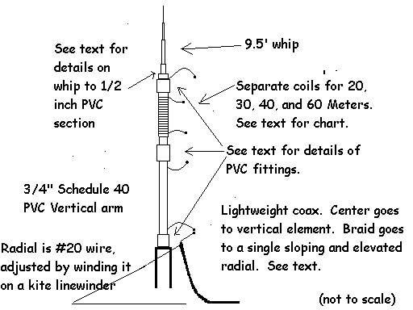

PARTS LIST
The PVC PARTS

One short section of 3/4” Schedule 40 PVC (you need about four feet)
One short section of 1/2“ Schedule 40 PVC (you need just two inches, and you might have that lying around the shop)

One ¾ inch slip slip PVC adapter.

One ¾ inch to ½ inch slip slip PVC adapter.

One ¾” inch slip to ½ inch threaded PVC adapter.

HARDWARE

One 3/8 by 24 threads per inch nut coupler. It’s about an inch long.

One 3/8 by 24 threads per inch bolt 1 and 1/4 inches long.

WIRE AND CONNECTORS

Radio Shack has speaker wire and blue wire connectors in stock.

One roll of #20 speaker wire ( more than enough for several antennas). RS Part # 278-1388. 75 feet of this is about $10. Gives you 150 feet of wire. You use this wire for winding the coils, and also for the adjustable radial to be described in the directions for building the antenna. It might be best to separate the wire right away so you are ready to wind the coils ahead of time.

Get two packages of blue male and female wire connectors. You will need at least a dozen of each. Spares are good in case you make a mistake in wiring.
The cost for a bag is about $2. There are five sets in each bag. Each coil requires two connectors, a male and a female. RS Part # 640-3133. By the way, I have been building these verticals without connectors. Just strip the wire and splice the ends when you are doing the initial tuning. Then, if you need to add wire to a coil, you can do that. When you are all tuned up and your antenna is working well, you can put the connectors on to neat up the installation. I notice that some of the matings between the male and female RS connectors are really tight.

You need one 3/8 by 24 ring connector. If you can’t find one, we’ll show in remarks how to compensate for that.

15 to 25 feet of RG58AU or RG8X mini coax. In the section about preparing the coax, you will wind a choke ( very easy to do ) to keep the rf off the outside of the coax.

MISCELLANEOUS PARTS

One 9 foot telescoping whip. I chose that whip because it has a nice ‘capture area’, is totally adjustable, and comes with a 3/8 by 24 inch thread on the bottom. Buddipole.com sells a black stainless steel version for $18.

A 6 inch by 4 inch piece of heavy cardboard for use as a linewinder.

You can use a BNC to Binding Post fixture, available at All Electronics.com if you want an easy way to connect the wires of the antenna to the coax.
This fixture has a female BNC connector on the bottom of it. One binding post is RED and the other is BLACK. It’s an alternative, and a good one.

TOOLS
Hacksaw
Vise
Small hammer
Wire brush
Wire cutters
Tool to crimp blue connectors to the wire
Drill
1/8 inch bit
Small hammer
A “picking tool” for preparing the coax
Solder and a soldering iron for attaching the radial to the coax braid
One roll of black plastic electrician’s tape

DIRECTIONS ON BUILDING THE BUDDISTICK

PREPARING THE PVC PARTS

Bottom Mount: This is the ½ inch female pipe thread to ¾ inch female slip part.

Vertical Arm:
Cut one piece of ¾ inch PVC to a length of 24 inches. This will be the vertical arm that supports the coil/whip. Drill a 1/8 inch about an inch end from each end, but not through to the other side. . You will snake a wire in from the outside and down the pipe and that wire will come out the hole on the bottom of the pipe.

Coil Forms:
20 Meters 2 ½”
30 Meters 4”
40 Meters 6 ½”
60 Meters 10”

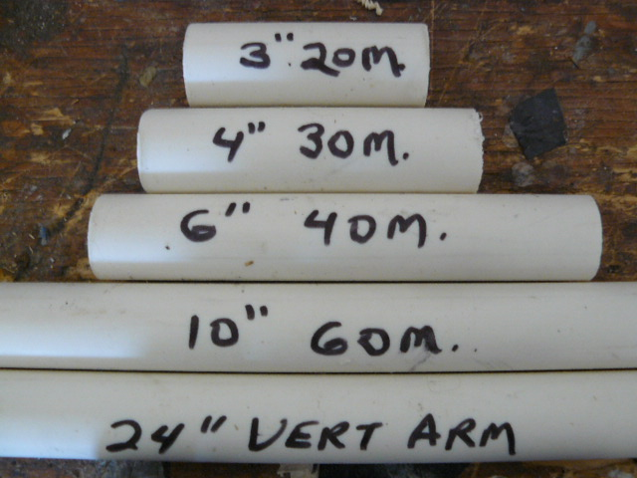

On each of the above forms, drill a 1/8 inch hole all the way through the pipe exactly an inch from each end. This will hold the wire to the coil forms.

ASSEMBLY AND WINDING OF COILS

20 Meters. Cut 35” of wire. 7 turns.
30 Meters. Cut 6’ of wire. 18 turns
40 Meters. Cut 14’6” of wire. 46 turns.
60 Meters. Cut 25’2” of wire. 82 turns.

The wire lengths have been planned so you have about 3 to 4 inches of wire on each end of the coil when you are through with the winding process.

You should already have cut the PVC forms for these coils, and you have already drilled a hole all the way through each form an inch from each end of the form.

Here’s an example of how the 30 Meter coil is wound. Take the bare end of the 6 foot wire and thread it through both holes on the PVC form. Keep about 3 ½ inches of wire out for one of the coil leads, which we will call one of the ‘tag ends’. Wind the rest of the wire on the form so that the coil turns are tightly placed one beside the other. On the side of the coil that has the lead coming out of it, count the number of turns you have wound on the form. What you want to do is to have 18 FULL turns on this form. The tag end of the wire is getting shorter, and you want to be sure that there are 18 turns exactly when you poke the end of that tag wire through the hole. There should be about 4 “ of wire on the tag end when you have finished.
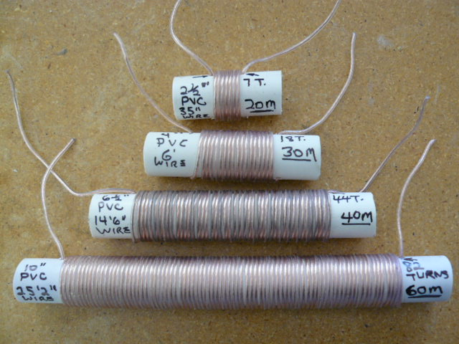

The other coils are wound the same way.

Installing the blue wire connectors on the coil wires and the vertical arm.

Strip the wire from the ends of the lead wires coming out of the coils so that about a half inch of bare wire is showing. Twist the tiny wires on that bare wire so that there are none sticking out. Fold the wire over one time to make a thicker wire.

Each coil will have one female wire connector and one male wire connector on the lead ends. Place the bared wire into the connectors and then take your crimper and secure the connection.

On the vertical arm, prepare a wire 30 inches long and install a female blue connector on either end of the wire. Push the naked end of the wire through the hole in the vertical arm on either end of the arm. Snake the wire down to the other end of the arm til it gets to the end. Put a bend in the wire and find the hole you drilled earlier an inch from the end of the arm. The wire goes out that hole. You may need a pair of needle-nosed pliers to get the wire through the hole. The wire will be accessible from the end of the pipe. Install a female blue connector on the end of that wire. This completes the wiring on the coils and the vertical arm.

Mount to hold the Telescopic Whip

Cut a section of ½ inch PVC pipe to a length of 2 inches. Prepare the 3/8 by 24 inch nut coupler by threading the 1 1/4 inch bolt into that coupler so that, when you measure the length of the nut coupler and bolt, it totals up to be the same length of the 2 inch long PVC pipe piece.
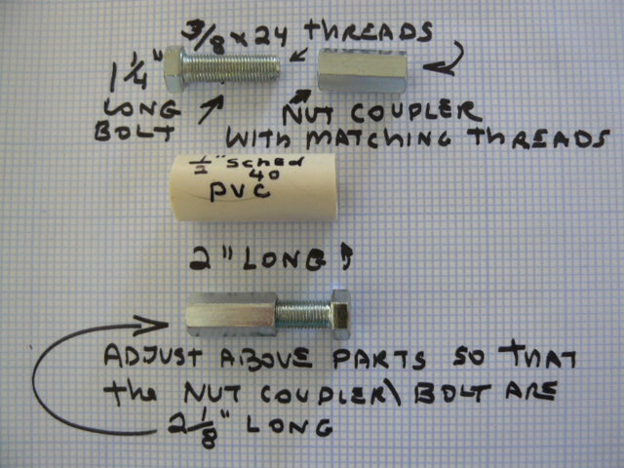

Take a small block of wood and place it on the vise or the workbench, and place the 2 inch PVC piece vertically on that wooden surface. Place the nut coupler directly on top of the PVC piece and start tapping the bolt so that the nut coupler is forced into the PVC as you tap away. The PVC may bulge a little bit. The final fixture will hold the nut coupler straight in the PVC because the added length of the bolt that you are tapping will seat itself in the PVC. Some nut couplers are slightly different in the hex-shaped OD, so if yours is slightly smaller than the inside of the PVC, wrap about five turns of black electrical tape around it using the ‘cut and try’ method when you tap it in.
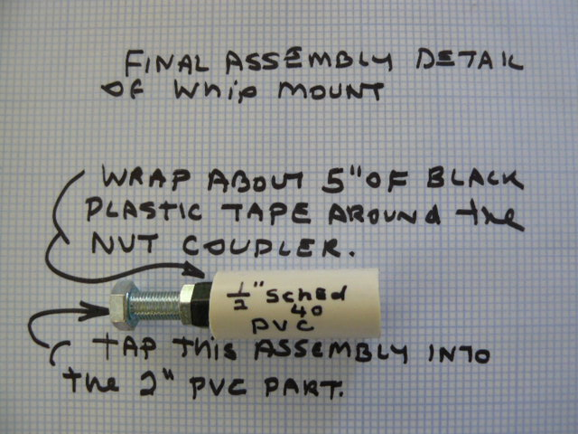

Now choose the last PVC adapter. It is the ½ inch slip to ¾ inch slip adapter. Tap the nut coupler piece into the ½ inch slip side of that adapter.

If you have a 3/8 ring connector, solder or crimp it to a piece of wire five inches long. On the end of that wire, install a male blue connector. The whip will thread directly into the nut coupler assembly you have just completed, and the wire will connect the whip to the rest of the antenna.
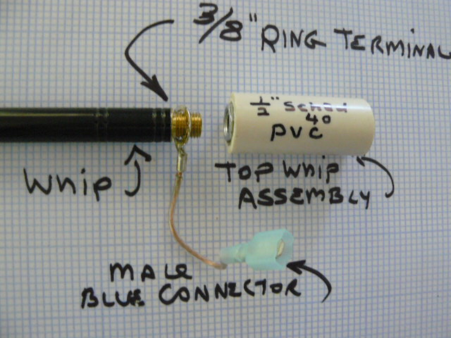

If you couldn’t locate a ring connector, just make a loop in the wire with a big enough hole to accommodate the threaded whip until you can get the correct size of ring connector. The ring connector makes the connection much better strength-wise.

Alternate ( 6’ ) Whip Mounting.

You can use a shorter whip by lengthening the piece of ¾ inch PVC that holds the whip in place to three feet in length. You install a wire inside that piece of plastic pipe to make up the difference in whip lengths. Prepare the wire in the same way you prepare the lower vertical arm section for this antenna.
You would have a male blue connector on the top side and a female blue connector on the bottom end. The new “Featherweight” whips from Buddipole.com work well for this alternative whip selection.

Alternate (16’) Whip Mounting.

There are lots of choices for the whip. Cabela’s.com sells 16’ crappie poles for ten bucks. These fiberglass poles fit perfectly over ¾ inch ID PVC. Just take the rubber foot off the pole and push the end of the pole over the PVC on the top of the section of PVC that holds the whip. Tape wire onto the pole. Look for the Cabela Classic crappie pole. It’s sturdy, and it gives you a big capture area for the Lower Bands especially. You will not need as many turns on the coil, of course. No turns would be needed on 20 Meters, because by attaching wire to the 16/5 foot crappie pole, you have a ¼ wave antenna from the start. This wire whip assembly would be too long for use on 17 Meters and up. Your coils for 30, 40, and 60 Meters would have a lot fewer turns. Adjust the radial for final resonance.

~~~~~~~~~~~~~~~~~~~~~~~~~~~~~~~~~~~~~~~~~~~~~~~~~~~~~~~~~~~~

ASSEMBLING THE PARTS

Let’s start from the bottom and work up. Thread the ½ inch threaded adapter onto the mast you have chosen.

Install the Vertical Arm on top of that adapter.

Choose a coil from those you have chosen to wind. Check the blue connectors. Place the coil on top of the Vertical Arm with the female blue connector on top and push the coil into the top of the Vertical Arm.

The Mount for the telescopic whip is then placed on top of the coil.

PREPARING THE COAX

Start with fresh coax, Install a good PL-259 on the radio end if that’s what your radio requires.

Make up a choke balun. Here’s how. Wrap your RG-58 coax in a 6” OD coil right below the feedoint. Put six turns of coax tightly together and secure those turns with black plastic tape.

On the antenna end of the coax, take a razor-blade knife and cut about Four inches of the outer cover off the coax. Separate the braid with a fine picking tool. Twist the braid so that at the end of that braid, you can crimp on a female blue connector.

Prepare the inner conductor by baring that wire and then by crimping a male blue connector to that wire. This is the ‘hot’ side of the coax, and this will be the wire that is connected to the female connector that goes up the vertical arm.

Use black electrician’s tape to protect the braid of the coax. Bend the braid back against the coax itself for a half inch or so, and tape that braid to the coax itself to provide some strain relief.

When you attach the coax to the mast close to the feedpoint, tape the coiled choke directly to the mast for strain relief.

Alternative Fixture for attaching the Coax.

I like this idea. You can use a female BNC to Binding Post adaptor to handle the wire. Here’s a picture of one: 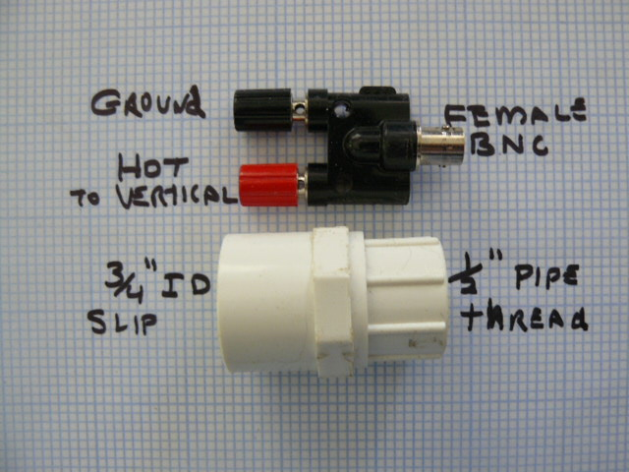

By attaching the above black and red connector to the PVC part pictured above, you will have a very easy way to connect the coax to the bottom of the fixture ( a BNC connection ) and it will make it easy for you to wire the antenna. See the assembly when it is finished:
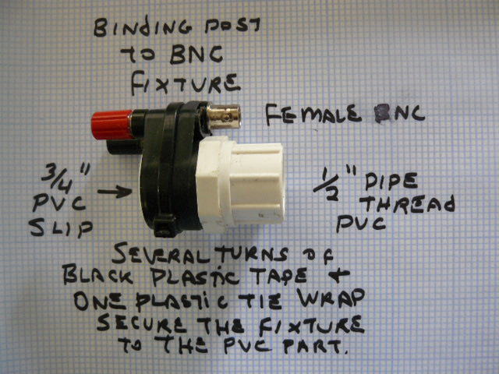

PREPARING THE WIRE RADIAL ASSEMBLY

Remember the piece of cardboard that was listed on the parts list under “Miscellaneous Parts”?

You can purchase a linewinder at any good kite shop, but you can make a very effective one by cutting one out of heavy cardboard stock. Cut a piece of cardboard about six inches long and four inches wide.

Make a “VEE” on each end of the rectangular shape. This will hold the wire onto the winder. Poke a hole in the cardboard, push the end of the radial through that hole and tie an overhand knot to secure the wire.

Cut a slot on one of the ends of the winder. This will hold the wire so that when the winder with the wire on it dangles down from the support you have it on, the wire will stay on the winder.

Connect a male blue connector on the end of the wire that you will use to attach to the braid of the coax later on. Wind all the wire on the linewinder

SUPPORTING THE HOMEBREW BUDDISTICK

You will need a support for this vertical antenna. If you already have a sturdy mast and tripod, you are all set to go. If not, you might consider purchasing a ‘painter’s pole’ from a do-it-yourself store. These popular supports for portable antennas work very well for the homebrew Buddstick.

There is an odd thread, an Acme thread, on the top of the painter’s poles.
In order for that thread to match the half inch pipe thread on the PVC mount you have prepared, you can wrap a couple of turns of black plastic electrician’s tape tightly around the Acme thread as a sort of gasket, and that is a good temporary solution. Buddipole.com sells “Center Tee Adapters”, which are a Delrin adapter that changes that odd thread to match the bottom of the homebrew Buddistick mount.

You can bungee the mast or painter’s pole to a fence or to building, but you should be able to reach the coil so that you can change bands quite easily.

FINAL ASSEMBLY OF THE ANTENNA

Assuming you have a suitable support and that you can reach the antenna to set it up and to change coils for changing bands, you now must put the parts together and connect the wires. Refer to the diagram shown earlier in these instructions.

Choose a coil…….for example, the 20 Meter coil, and insert that coil into the top end of the vertical arm assembly. Make sure the blue wire with the female connector is at the top of the coil.

Put the mount with the telescoping whip on top of the 20 Meter coil.

Plug the male wire from the whip assembly into the female wire on the top of the coil.

Plug the male wire connector from the coil to the female wire connector coming out of the vertical element. (Use the same procedure when you change coils (bands).

You have a choice on how to connect the coax. Do it directly as shown below:

On the bottom of the antenna, connect the female blue wire connector to the hot side (male blue connector) which goes to the inner conductor of the coax assembly.

The wire that goes to the linewinder with the single radial is attached to the braid of the coax, which has a female connector on it. The radial wire has a male blue connector.

OR

If you decide to use the BNC to Binding Post idea, it will be easier to wire the coax. The RED binding post will be connected to the wire going to the vertical element, and the BLACK binding post will be connected to the radial and the wire wound on the kite linewinder.

SETTING UP THE BUDDISTICK

So, you have the vertical element going straight up from your support. Now, to get this antenna on the air, you will need “the other half” of the vertical, the radial.

We have chosen a single radial for this job. This radial has been designed to be placed at all times above the ground by at least two feet. You can choose a feed point of say 8 or more feet above the ground for where the coax meets the vertical element. From that point, the radial on the line winder you have prepared, should slope down toward the ground, and then be placed on shrubbery or a non-conducting electric fencepost which will keep it off the ground by at least 24 inches until the end of the wire.

The whip length and coil inductances have been chosen ahead of time, so the only parameter you have to change to get a very low SWR is the length of the radial. And you have some latitude on these lengths. But to get on the air quickly, we have matched the antenna with specific radial lengths. Here is a chart for you to follow so you can quickly tune up.

60 Meters 41 feet
40 Meters 32 feet
30 Meters 22 feet
20 Meters 15 feet
17 Meters 11 feet
15 Meters 9 feet
12 Meters 8’4”
10 Meters 7 feet

These are estimates for radial length. You can start with these lengths and change them if you find that in your location, a bit more or less from the above lengths will work better over your particular ground.

FINAL TUNING OF THE HOMEBREW BUDDISTICK

This is the place where you need to actually hook up a radio and see how this antenna works at your location.

Set it up for 20 Meters. Get into the portion of the band where it’s not busy, and where your license allows you to transmit.

Set the antenna up as described previously. Pull the radial out to the side of the mast/tripod and secure it on shrubbery or on an electric fencepost to keep it off the ground.

If you own an antenna analyzer, this is the time to put it into action. Set up the analyzer, deploy the radial, and check the frequency where the dip is….ie where the antenna is resonant. It ideally should be about 14 Mhz.

If it’s too low in frequency, say, 13.6 Mhz, most probably the radial is a bit long. Just take a couple of wraps on the line winder at the far end of the radial and check the analyzer again. Keep this process up until you find that the frequency you want is the frequency that the analyzer is indicating.

You should have a flat SWR ( close to 1:1) on most of the 20 Meter band.
Other bands work the same way. The frequencies are different, but the concept is the same. Choose the coil for the band you want to use….then consult the radial chart. Then you can try different radial lengths to get to the exact frequency you are seeking.

If you don’t have an antenna analyzer, and don’t know someone you can borrow one from, then the process is the same, but you will have to use the power meter on your radio (with the meter set on POWER) or the SWR meter on the radio.

It’s just a matter of selecting the right coil, pulling the whip up fully, and then adjusting the radial to resonate on your frequency of choice.

Note that on 17 Meters, there will be NO COIL in the circuit. Make sure all the whip sections are up fully. Bypass the coil. Use 11 feet of wire for the radial.

15 Meters: NO COIL again. Whip out fully. The radial is just 9 feet long.
12 Meters: NO COIL, and see that the whip is out just 56”. The radial is 8 feet 4 inches long.

For 10 Meters, NO COIL and note that the whip is out the same as it is for 12 Meters: 56”. The radial is 7 feet long.

QUESTIONS ON PARTS OR TUNING?

Feel free to email me directly at this address: W3FF@buddipole.com Have fun with the build, modify it, improve it, and let me know how you are doing with the design.

W3FF 4/2010

